Atmosphere and Weather Vocabulary
Vocabulary Concept | Definition | Visual Representation/Explanation
Cyclone | A swirling center of low air pressure. | 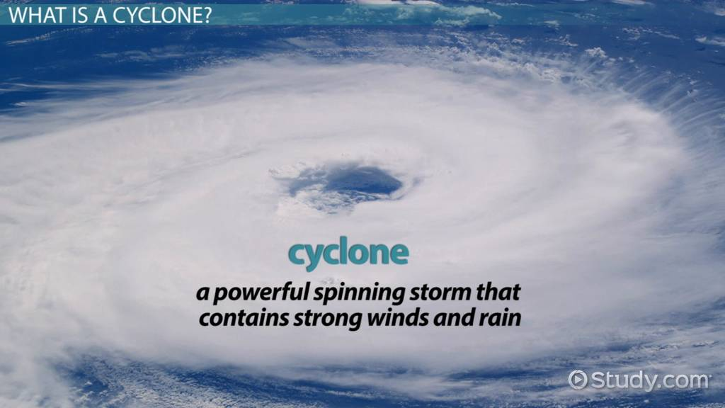
Anticyclone | A high-pressure center of dry air. | 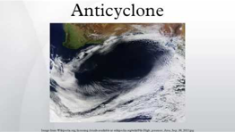
Storm | A violent disturbance in the atmosphere. | 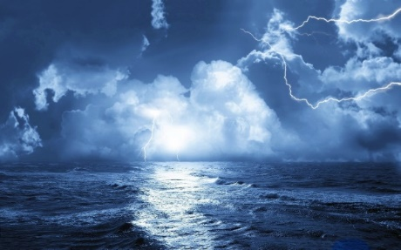
Thunderstorm | A small storm often accompanied by heavy precipitation and frequent thunder and lightning. | 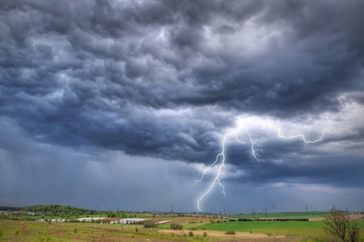
Lightning | A sudden spark, or energy discharge, caused when electrical charges jump between parts of a cloud, between nearby clouds, or between a cloud and the ground. | 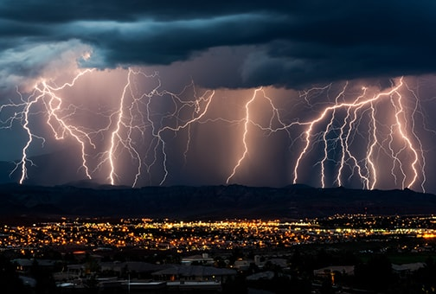
Tornado | A rapidly whirling, funnel-shaped cloud, that reaches down from a storm cloud to touch Earth’s surface. | 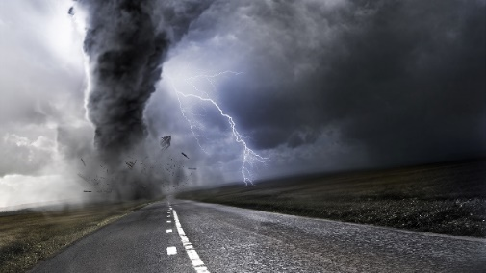
Hurricane | A tropical storm that has winds of 118 kilometers per hour or higher. | 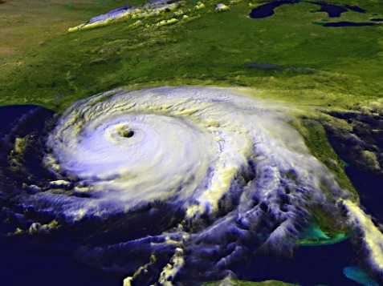
Storm Surge | A “dome” of water that sweeps across the coast where a hurricane lands. | 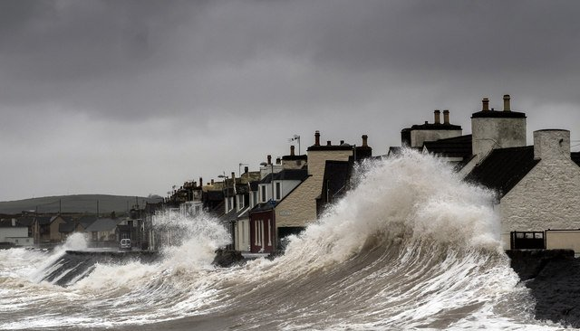
Meteorologist | A scientist who studies the causes of weather and tries to predict it. | 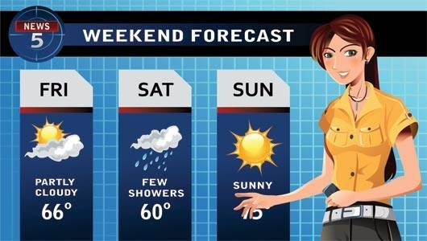
Isobar | A line on a weather map that joins places that have the same air pressure. | 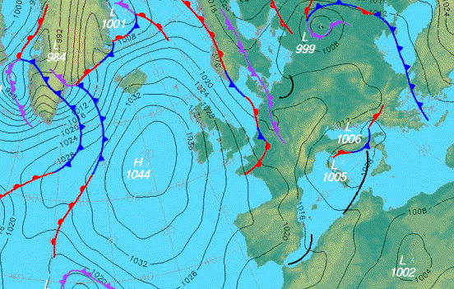
Isotherm | A line on weather map that joins places that have the same temperature. | 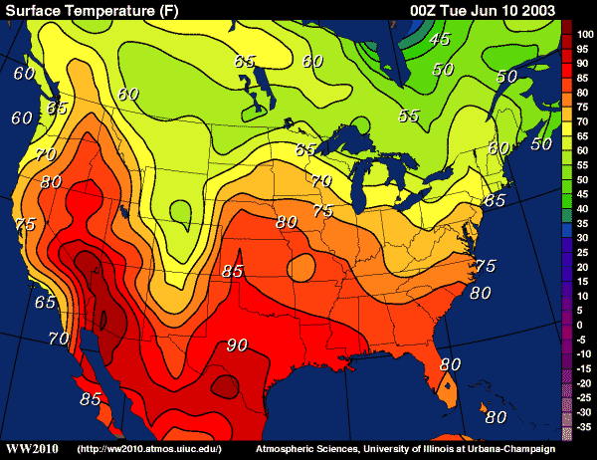
Cumulonimbus Clouds | Clouds that are dense towering vertical cloud, forming from water vapor carried by powerful upward air. If observed during a storm, these clouds may be referred to as thunderheads. | 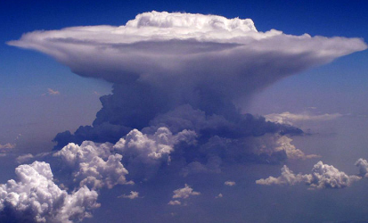
Monsoon | Sea or land breeze over a large region that changes directions with seasons. | 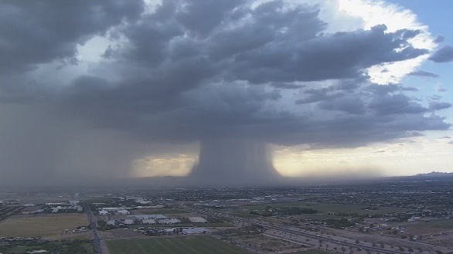
Cirrus Clouds | Wispy, feathery clouds made mostly of ice crystals that form at high levels. | 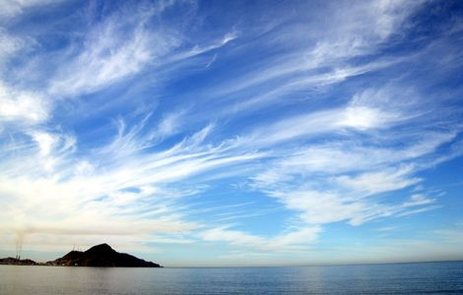
Cumulus Clouds | Fluffy, white clouds, usually flat bottoms, that look like rounded piles of cotton. | 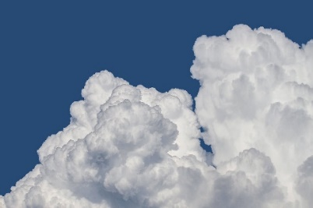
Stratus Clouds | Clouds that form in flat layers and often cover much of the sky. | 